*2024 LIFEday***SOCIAL PACKET**Variable content in green.   
Please download images at <https://cpcfriends.org/lifeday-resources/>.  
Don’t forget to tag CPC in your posts @cpcfriends!

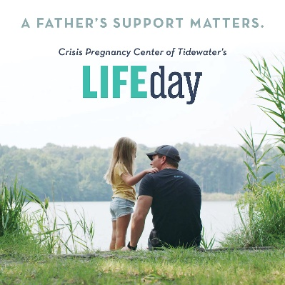

*Download this image at* [*https://cpcfriends.org/lifeday-resources/*](https://cpcfriends.org/lifeday-resources/)

**Post #1 Caption:**

A nationwide survey of abortion-minded women revealed an important finding: The father of the baby is the #1 influence in a woman’s decision of whether or not to have an abortion.*

Join [YOUR CHURCH'S NAME HERE] as we support Crisis Pregnancy Center of Tidewater by joining them in speaking up for LIFE! Pick up a baby bottle on Sunday and fill it with spare change, cash, and checks to help CPC save lives, spare hearts, and spread the gospel of Jesus Christ.

*“Study of Women who have had an Abortion and Their Views on Church”, LifeWay Research

*Download this image at* [*https://cpcfriends.org/lifeday-resources/*](https://cpcfriends.org/lifeday-resources/)

**Post #2 Caption:**

At this age, hands and feet are developing.*

THIS IS A PERSON CREATED IN GOD’S IMAGE.

Don’t forget! This Sunday, pick up a baby bottle to fill with spare change, cash, and checks and join CPC in being the hands and feet of Jesus to the moms, dads, and families of South Hampton Roads. Your change can change lives!

*South Carolina Department of Health and Environmental Control. (2015). Embryonic and Fetal Development. https://scdhec.gov/sites/default/files/Library/ML-017049.pdf

---------------------------------------------------------------------------------------------------------------------------------------

*Download this image at* [*https://cpcfriends.org/lifeday-resources/*](https://cpcfriends.org/lifeday-resources/)

**Post #3 Caption:**

“I did the math. So far, we are at $320 spent on the baby. We got a crib from CPC. We got all the diapers and wipes that we’ll ever need. They set us up so well for success.”

- Abigail, baby Asher’s mom and a patient of CPC’s pregnancy medical clinics

[YOUR CHURCH'S NAME HERE] is partnering with the Crisis Pregnancy Center of Tidewater this January. Pick up a baby bottle to fill with spare change, cash, and checks to donate to CPC and Celebrate the Sanctity of Human Life! Your gift can help make an impact in the lives of more families like Abigail, Joseph, and baby Asher.

*Download this image at* [*https://cpcfriends.org/lifeday-resources/*](https://cpcfriends.org/lifeday-resources/)

**Post #4 Caption:**

“Fast forward 25 years. As I was sitting in an abortion recovery class, the Holy Spirit revealed that my sickness, depression, and crying were all associated with my abortion. I had been ill for 25 years, however since that day, I have been free – physically, emotionally, and spiritually.”

- Chandra, former CPC staff member

Did you know that Crisis Pregnancy Center of Tidewater offers abortion recovery small groups for both men and women? Learn more about this ministry at <https://cpcfriends.org/afterabortion/>.

Stand with CPC and [YOUR CHURCH'S NAME HERE] by participating in our LIFEchange baby bottle campaign this January! Pick up your baby bottle this Sunday to fill with spare change, cash, and checks to donate to the ministry of CPC.   
---------------------------------------------------------------------------------------------------------------------------------------

*  
Download this image at* [*https://cpcfriends.org/lifeday-resources/*](https://cpcfriends.org/lifeday-resources/)

**Post #5 Caption:**

Abortion has become more convenient than ever with the ability to order at-home abortions. The United States is being flooded with mailed abortion pills from both inside and outside the country.*

Join Crisis Pregnancy Center of Tidewater and [YOUR CHURCH'S NAME HERE] as we stand for the Sanctity of Human LIFE. This Sunday, pick up a baby bottle to fill with spare change, cash, and checks to donate and become part of a movement of healing and LIFE in our country.

*Society of Family Planning (2023). #WeCount Report: April 2022 to June 2023. https://doi.org/10.46621/218569qkgmbl

*Download this image at* [*https://cpcfriends.org/lifeday-resources/*](https://cpcfriends.org/lifeday-resources/)

**Post #6 Caption:**

CPC is so happy to be offering LIFE-revealing ultrasounds at 4 of their clinics in South Hampton Roads!

Support this new chapter in the ministry of CPC by participating in our LIFEchange baby bottle campaign this January! Pick up your baby bottle this Sunday to fill with spare change, cash, and checks to support the moms, dads, and families of South Hampton Roads.