*2025 LIFEday***SOCIAL PACKET**Variable content in green.   
Please download images at <https://cpcfriends.org/lifeday-resources/>.  
Don’t forget to tag CPC in your posts @cpcfriends!

*Download this image at* [*https://cpcfriends.org/lifeday-resources/*](https://cpcfriends.org/lifeday-resources/)

**Post #1 Caption:**

Studies show that abortions have increased since the overturning of Roe v. Wade.  More than one million babies were aborted in the US in 2023. The highest rate in more than a decade.

Join [YOUR CHURCH'S NAME HERE] as we support Crisis Pregnancy Center of Tidewater by joining them in speaking up for LIFE! Pick up a baby bottle on Sunday and fill it with spare change, cash, and checks to help CPC save lives, spare hearts, and spread the gospel of Jesus Christ.

SOURCE: McPhillips, Deidre. “US Abortions Reach Highest Level in over a Decade, Sparked by Surge in Medication Abortion.” *CNN*, CNN, 19 Mar. 2024, [www.cnn.com/2024/03/18/health/abortion-data-guttmacher/index.html](https://www.cnn.com/2024/03/18/health/abortion-data-guttmacher/index.html)

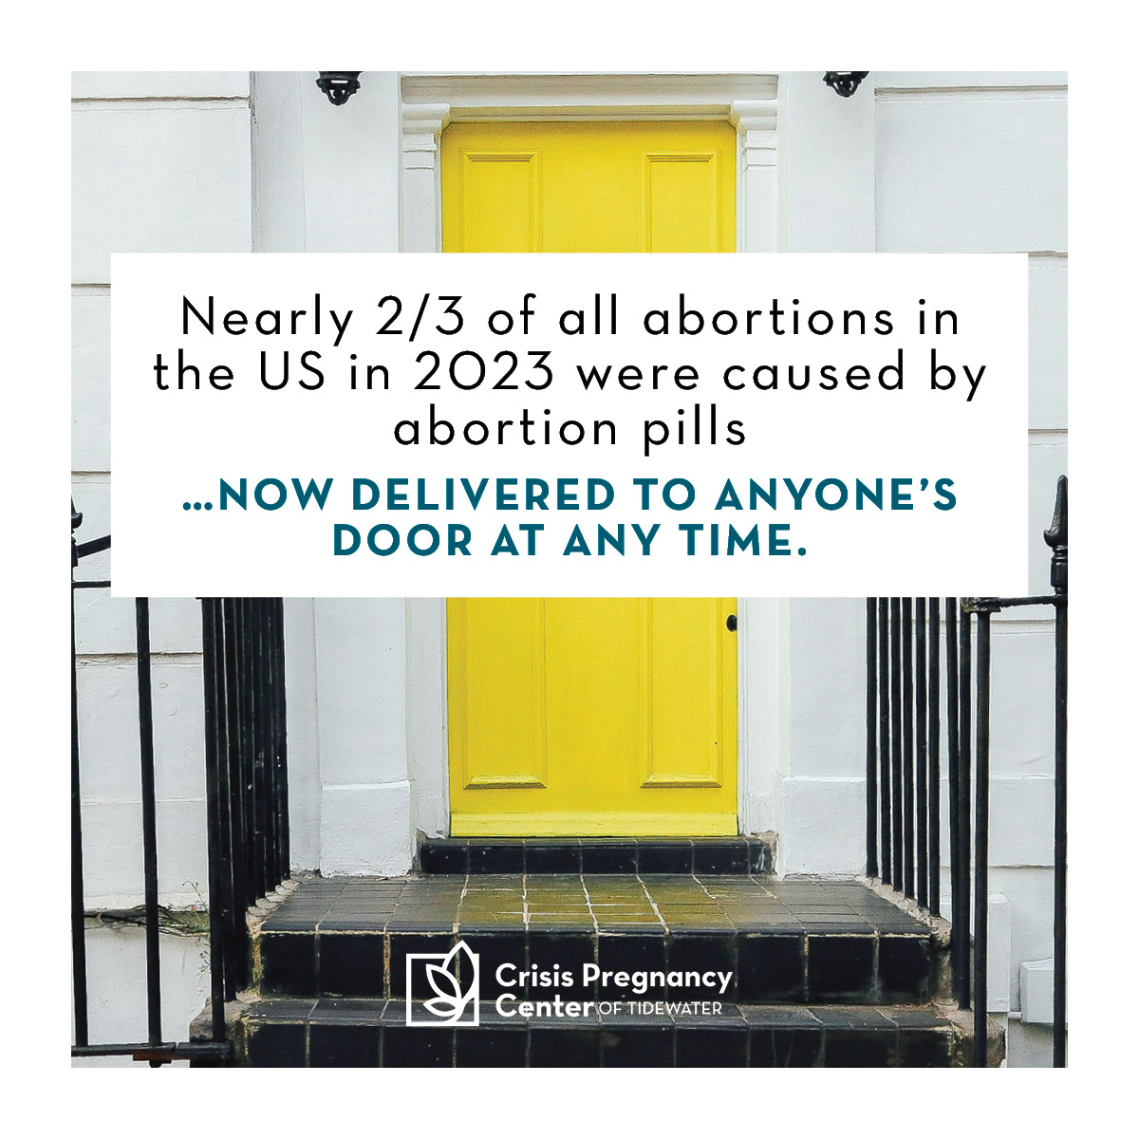

*Download this image at* [*https://cpcfriends.org/lifeday-resources/*](https://cpcfriends.org/lifeday-resources/)

**Post #2 Caption:**

Don’t forget! This Sunday, pick up a baby bottle to fill with spare change, cash, and checks and join CPC in being the hands and feet of Jesus to the moms, dads, and families of South Hampton Roads. Your change can change lives!

SOURCE: McPhillips, Deidre. “US Abortions Reach Highest Level in over a Decade, Sparked by Surge in Medication Abortion.” *CNN*, CNN, 19 Mar. 2024, [www.cnn.com/2024/03/18/health/abortion-data-guttmacher/index.html](https://www.cnn.com/2024/03/18/health/abortion-data-guttmacher/index.html)

---------------------------------------------------------------------------------------------------------------------------------------

*Download this image at* [*https://cpcfriends.org/lifeday-resources/*](https://cpcfriends.org/lifeday-resources/)

**Post #3 Caption:**

“Your eyes saw my unformed substance; in your book were written, every one of them, the days that were formed for me, when as yet there was none of them.”  
Psalms 139:16 ESV

[YOUR CHURCH'S NAME HERE] is partnering with the Crisis Pregnancy Center of Tidewater this January. Pick up a baby bottle to fill with spare change, cash, and checks to donate to CPC and Celebrate the Sanctity of Human Life! Your gift can help make an impact in the lives of more children like baby Tristan (pictured).

*Download this image at* [*https://cpcfriends.org/lifeday-resources/*](https://cpcfriends.org/lifeday-resources/)

**Post #4 Caption:**

CPC’s 4 medical clinics and one satellite resource center serve moms, dads, and pre-born babies in all 5 cities of South Hampton Roads.

Join Crisis Pregnancy Center of Tidewater and [YOUR CHURCH'S NAME HERE] as we stand for the Sanctity of Human LIFE. This Sunday, pick up a baby bottle to fill with spare change, cash, and checks to donate and become part of a movement of healing and LIFE in our community.

---------------------------------------------------------------------------------------------------------------------------------------

*  
  
Download this image at* [*https://cpcfriends.org/lifeday-resources/*](https://cpcfriends.org/lifeday-resources/)

**Post #5 Caption:**

Stand with CPC and [YOUR CHURCH'S NAME HERE] by participating in our LIFEchange baby bottle campaign this January! Pick up your baby bottle this Sunday to fill with spare change, cash, and checks to donate to the ministry of CPC.

*Download this image at* [*https://cpcfriends.org/lifeday-resources/*](https://cpcfriends.org/lifeday-resources/)

**Post #6 Caption:**

Pick up your baby bottle this Sunday to fill with spare change, cash, and checks to support more families like Claudia’s here in South Hampton Roads.

---------------------------------------------------------------------------------------------------------------------------------------

*Download this image at* [*https://cpcfriends.org/lifeday-resources/*](https://cpcfriends.org/lifeday-resources/)

**Post #7 Caption:**

Pick up your baby bottle this Sunday to fill with spare change, cash, and checks to support more families like Karla’s here in South Hampton Roads.

*Download this image at* [*https://cpcfriends.org/lifeday-resources/*](https://cpcfriends.org/lifeday-resources/)

**Post #8 Caption:**

Pick up your baby bottle this Sunday to fill with spare change, cash, and checks to support more families like DeNeisha’s here in South Hampton Roads.